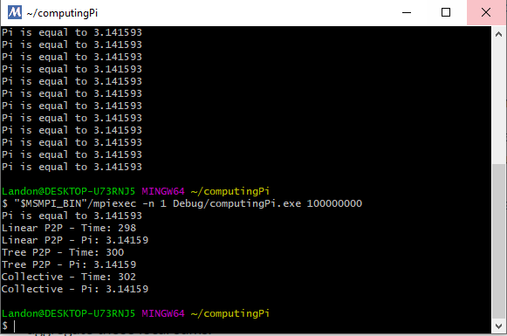

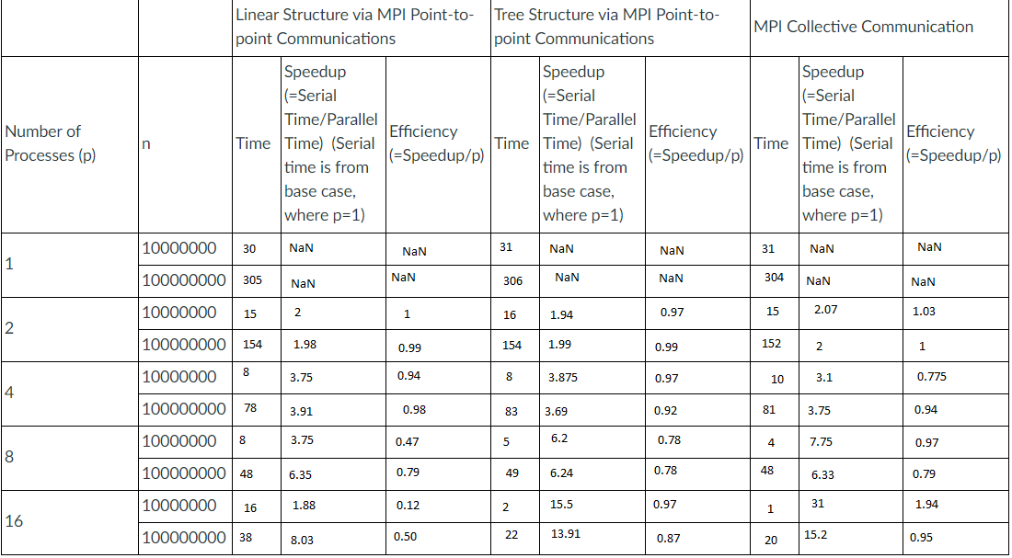

This code uses different structures of MPI parallelism to divide up the calculation of pi between different processes. Each structure with a low number of processes runs in about the same efficiency as each other but as you increase the number of processes, the Collective Communication tends to become the most efficient. Each structure breaks the calculation of pi up into chunks to make the calculation faster and more efficient. Amdahl’s Law can be demonstrated with these structures. For example, the linear structure becomes much and much less efficient after increasing the number of processes, the tree structure becomes efficient and stays efficient with more processes than the linear, but the collective structure starts less efficient and becomes more efficient for way many more processes.